LP and epithelium dimensions (Z x X x Y): 15 mm x 1.6 mm x 22.09 mm

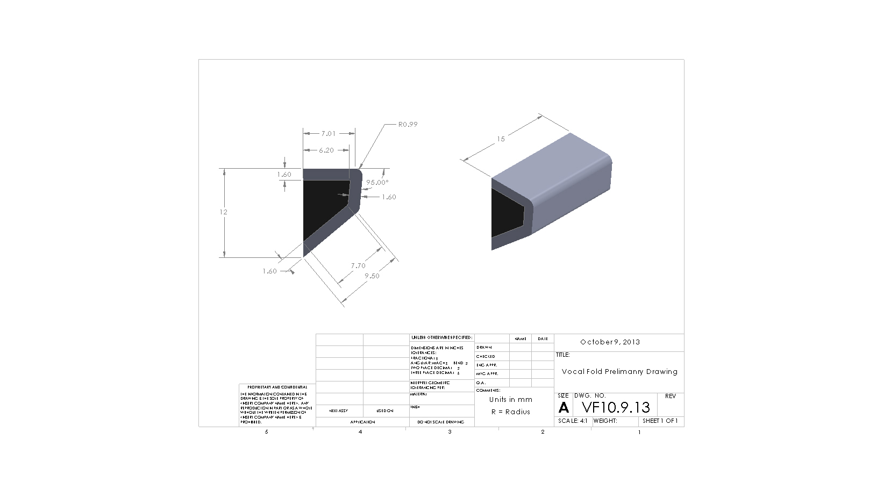

Table 1: Different Definitions of Cover-Body of VF LP1

|  |  |  |  |
| --- | --- | --- | --- |
|  | Cover | Body | Transition |
| Hirano2,3 | Epithelium, SLP | Vocalis muscle | MLP, DLP |
| Titze4 | Epithelium, SLP, ILP | DLP, Vocalis muscle |  |
| Hammond5 | Epithelium. SLP, ILP | MLP, DLP, Vocalis muscle |  |
| Dikkers6 | Epithelium, SLP | Conus elasticus, Vocalis Muscle |  |

[1] Hartnick, Christopher J., Reza Rehbar, and Vinay Prasad. "Development and maturation of the pediatric human vocal fold lamina propria." *The Laryngoscope* 115, no. 1 (2005): 4-15.

[2] Hirano M. Structure and vibratory behavior of the vocal folds. In: Sawashima M, Franklin S, eds. Dynamic Aspects of Speech Production. Tokyo: University of Tokyo Press, 1977;13–30.

[3] Wind J. On the Phylogeny and Ontogeny of the Human Larynx. A Morphological and Functional Study. Groningen, the Netherlands: Wolters-Noordhoff Publishing, 1970; 89 –108

[4] Titze IR. Principles of Sound Production. Englewood Cliffs, NJ: Prentice-Hall, 1994.

[5] Hammond TH, Gray SD, Butler J, et al. Age- and genderrelated elastin distribution changes in human vocal folds. Otolaryngol Head Neck Surg 1998;119:314 –322.

[6] Dikkers F. Benign Lesions of the Vocal Folds: Clinical and Histopathological Aspects. Groningen: Rijksuniversiteit Groningen, 1994

Table 2: VF Layers according the elastin and collagen organization

|  |  |  |  |  |
| --- | --- | --- | --- | --- |
| VF Layers | | | Thickness according to collagen organization *,*** | Thickness according to elastin organization *,*** |
| Superficial  ↓  Deep | LP vibratory cover | Epithelium |  |  |
| Superficial LP | 13% ± 20-64% of LP 2 | 25-35% of LP 10 |
| Transition | Intermediate LP** | 51% ± 28-61% of LP 2 | 45-55% of LP10 |
| VF body | Deep LP | 36% ± 6-18% of LP 2 | 10-30 of LP% |
| Thyroarytenoid Muscle | - | - |

Table 3: VF Layers according the collagen organization

|  |  |  |  |  |
| --- | --- | --- | --- | --- |
| VF Layers | | | Thickness according to collagen organization *,*** | |
| Superficial  ↓  Deep | LP vibratory cover | Epithelium | 0.05mm3 (5-25 cells 1) | |
| Superficial LP | 1245 ± 668-170 μm 1,2 | 166 ± 51-322 μm 2 |
| Transition | Intermediate LP** | 633 ± 188-1077 μm 2 |
| VF body | Deep LP | 446 ± 360-496 μm 2 |
| Thyroarytenoid Muscle | - | |

* Modern description of microanatomy of hvf5, 6, 7 by examining amount of fibrous proteins (collagen and elastic fibers) in ECM. Lack of consensus regarding exact boundaries of cover and body with regards to relationship between histologic structures and functional properties 4, will refer to layers according to collagen organization2

** Cover-body theory of phonation. Superficial tissue termed the cover and deeper tissue called body5,6,7. Some studies include intermediate layer in definition of vibrating cover8,9, here we consider to be part of the transitional layer10,11,12.

*** thickness lateral to the superior and leading edge of the vocal fold

[1] Kaiser, M. L., M. Rubinstein, D. E. Vokes, J. M. Ridgway, S. Guo, M. Gu, R. L. Crumley, W. B. Armstrong, Z. Chen, and B. J. F. Wong. "Laryngeal epithelial thickness: a comparison between optical coherence tomography and histology." *Clinical Otolaryngology* 34, no. 5 (2009): 460-466.

[2] Prades, Jean-Michel, Jean Marc Dumollard, Sébastien Duband, Andrei Timoshenko, Céline Richard, Marie Dominique Dubois, Christian Martin, and Michel Peoc’h. "Lamina propria of the human vocal fold: histomorphometric study of collagen fibers." *Surgical and radiologic anatomy* 32, no. 4 (2010): 377-382.

[3] Hirano, Minoru. "Phonosurgery: basic and clinical investigations." *Otologia (Fukuoka)* 21, no. suppl 1 (1975): 239-260.

[4] Hartnick CJ, Rehbar R, Prasad V (2005) Development and maturation of the pediatric human vocal fold lamina propria. Laryngoscope 115:4–15

[5] Hirano M (1974) Morphological structure of the vocal cord as a vibrator and its variations. Folia Phoniatr 26:89–94

[6] Hirano M (1975) Phonosurgery: basic and clinical investigations. Otologia (Fukuoka) 21(suppl 1):239–260

[7] Hirano M, Kuritas S, Nakashima T (1983) Growth, development and aging of human vocal folds. In: Bless DM, Abbs JH (eds) Vocal fold physiology. College-Hill Press, San Diego, pp 22–43

[8] Hammond TH, Gray SD, Butler JE, Zhou R, Hammond E (1998) Age and gender-related elastin distribution changes in human vocal folds. Otolaryngol Head Neck Surg 119:314–322

[9] Hammond TH, Gray SD, Butler JE (2000) Age- and gender-related collagen distribution in human vocal folds. Ann Otol Rhinol Laryngol 109:913–920

[10] Gray SD, Titze IR, Alipour F, Hammond TH (2000) Biomechanical and histologic observations of vocal fold Wbrous proteins. Ann Otol Rhinol Laryngol 109:77–85

[11] Hirano M. Structure of the vocal fold in normal and disease states. Anatomical and physical study. ASH A Rep 1981 ; 11 : 11-30.

[12] Hirano M. Phonosurgery: basic and clinical investigations. Otol Fukuoka 1975;21:239-442.